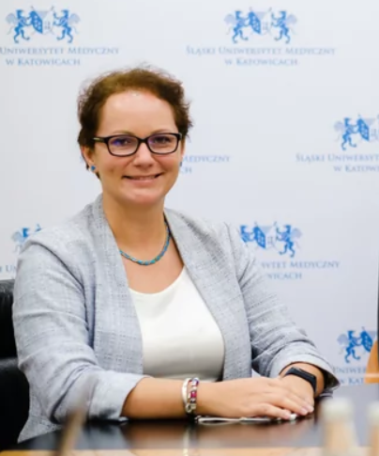

Why elderly care is so important for me:

**Healthy ageing** is one of the most important, but also hard, **public health challenges**. The thing that each of us can do for ourselves, **every day is a proper diet** and any age is good to start taking care of yourself. Food/nutrition policy is also very important in order to facilitate and prompt these correct, individual, everyday choices. In the era of numerous neurodegenerative diseases, neurodietetics is a promising solution and the prevention of malnutrition is an important aspect.

* PhD, MBA in Healthcare
* Assistant, Department of Health Policy, Medical University of Silesia, Katowice, Poland
* Clinical dietitian, SezaM–Association of patients with multiple sclerosis,

Specialisation or expertise: As dietician and public health specialist I combine both disciplines in my research. My main research area is health and food/nutrition policy. I am/was a researcher in many international scientific projects in cooperation with Ministry of Health, European Commission, World Health Organization (i.e. **JANPA**-Joint Action on Nutrition and Physical Activity; **JAHEE**-Joint Action on Health Equity Europe; **EPHOs**-Essential Public Health Operations; **Best Re-MaP**-Joint Action on implementation of validated best practices (in Nutrition); **Com.HeNet**-Competences in Health Network Management; **PEN**-Effectiveness of existing policies for lifestyle interventions Policy Evaluation Network; Public Health Expert in **Map of Health Needs**).

*Publications:* <https://ppm.sum.edu.pl/info/author/SUMc6414dce37754923a755746d06098244/Profil%2Bosoby%2B%25E2%2580%2593%2BKatarzyna%2B%2BBruka%25C5%2582o%2B%25E2%2580%2593%2B%25C5%259Al%25C4%2585ski%2BUniwersytet%2BMedyczny%2Bw%2BKatowicach?r=publication&ps=20&tab=publications&sort=&lang=pl&pn=1>

*Relevant publications:*

Improving the food environment in kindergartens and schools: an overview of policies and policy opportunities in Europe. Kovacs Viktoria Anna, Messing Sven, Sandu Petru [i in.], Food Policy, 2020, vol. 96, s.1-10. DOI:10.1016/j.foodpol.2020.101848

Assessment of menus in a selected social welfare home with regard to nutritional recommendations. Grochowska-Niedworok Elżbieta, Brukało Katarzyna, Całyniuk Beata [i in.], Int.J.Med.Health Sci. - Biomed.Bioeng.Pharm.Engin., 2019, vol. 13, nr 1, s.13-17

Designing solutions for the retirement system - in search of balance between economy and health. Romaniuk Piotr, Brukało Katarzyna, Frontiers in Public Health, 2016, vol. 4, nr [art.] 184, s.1-6. DOI:10.3389/fpubh.2016.00184