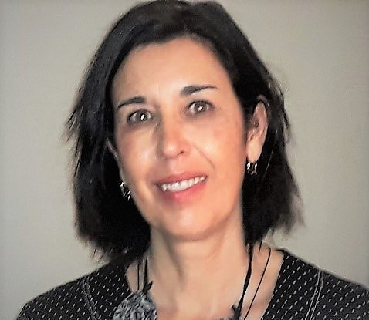 | Mar Ruperto, Spain  Why elderly care is so important for me:  "Older adults are a group vulnerable to nutritional disorders in which nutritional care from the nutritionist's perspective allows to prevent and actively treat malnutrition and to improve both healthy ageing and clinical outcomes and quality of life"
- Senior Clinical dietitian, PhD
- Professor of Clinical Nutrition and researcher at University San Pablo CEU, Madrid. Spain.
Specialisations or expertise: My lines of research focus on the area of knowledge of nutrition in different clinical conditions, in particular, nutritional screening and assessment, analysis of body composition and hydration pattern, new markers of malnutrition and inflammation, and the treatment of disease-related malnutrition in adults and the elderly population. In addition, other specific research areas in Nutrition include chronic kidney disease and haemodialysis patients.

Publications: https://pubmed.ncbi.nlm.nih.gov/?term=Ruperto+M
https://pubmed.ncbi.nlm.nih.gov/?term=Ruperto+lopez+M

-Jones S, Archer E, Ongan D, et al. Nutritional interventions in older people with COVID-19: an overview of the evidence [published online ahead of print, 2021 Dec 8]. Nurs Older People. 2021;10.7748/nop.2021.e1368. doi:10.7748/nop.2021.e1368
- Puga AM, Ruperto M, Samaniego-Vaesken ML, Montero-Bravo A, Partearroyo T, Varela-Moreiras G. Effects of Supplementation with Folic Acid and Its Combinations with Other Nutrients on Cognitive Impairment and Alzheimer's Disease: A Narrative Review. Nutrients. 2021;13(9):2966. Published 2021 Aug 26. doi:10.3390/nu13092966

